

NAME: BISMA FATIMA
CLASS: CS A
ROLL NO: F24605036
COURSE: COMPUTER NETWORK
COURSE CODE: CS-271
LECTURER: SIR NAVEED YOUSAF

OPEN ENDED LAB

Question No.1. (CLO 3, PLO 5) [Marks 10]
A technology company named TechVerse Solutions operates three main departments: Research & Development (R&D), Marketing, and Finance. You are tasked with designing a network topology in Cisco Packet Tracer to connect all three departments efficiently and securely.
Connectivity Requirements:
- Connect all departments using three routers.
- Each department must include a switch and at least three PCs.
- Assign appropriate IP addressing using subnetting.
- Configure RIP routing protocol for dynamic route sharing between routers.
- Add one static route per router for a specific remote network (to test hybrid routing).
- The network must allow full communication between all departments.
- The design should be scalable for future departmental additions.
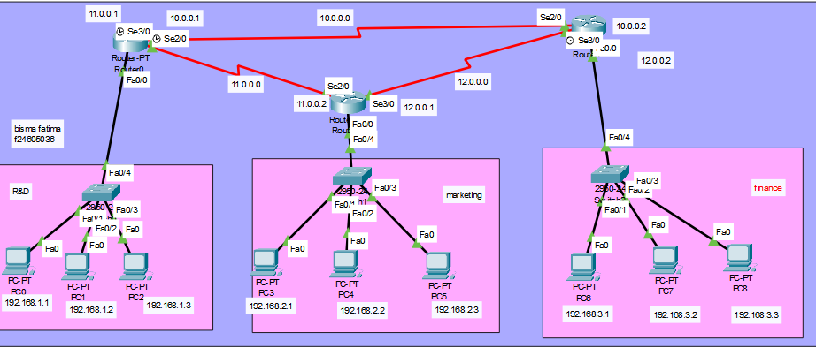
Additional Requirements:
- Verify network functionality by testing connectivity within each department and between departments using both real-time and simulation modes.
Real time:
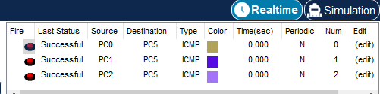

Simulation:
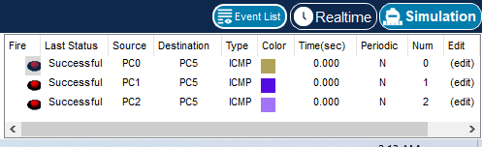

- Document the network configuration, including IP addressing details, routing setup, and any basic security configurations applied.

Show ip interface brief:
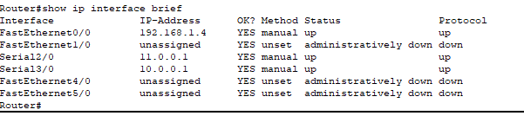

Configuration for R1:
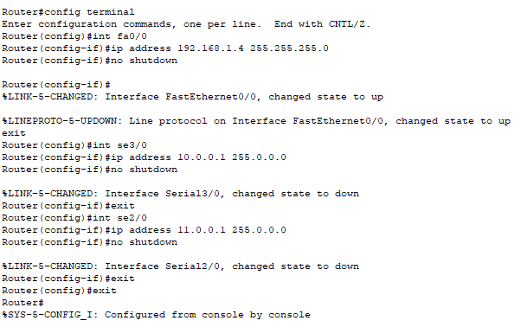
Configuration for R2:

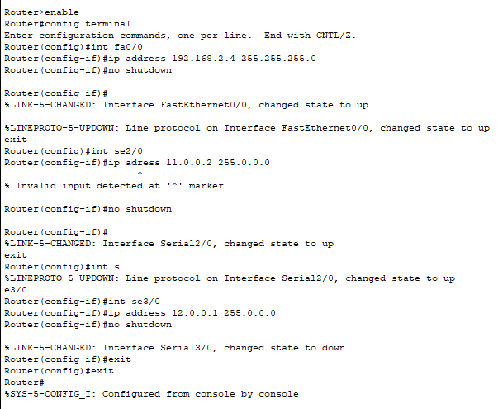
Configuration for R3

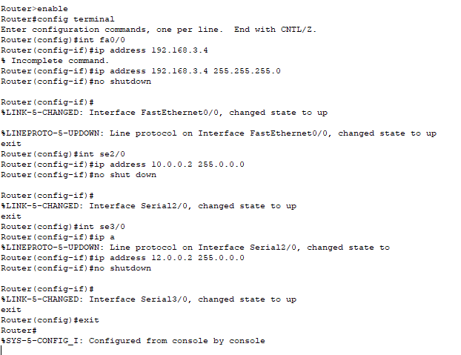
RIP configuration for R1:
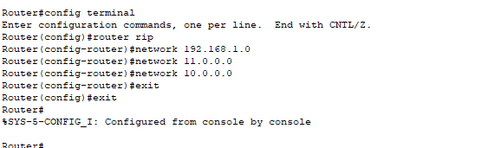

RIP configuration for R2:

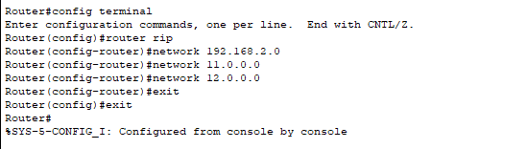

RIP configuration for R3:

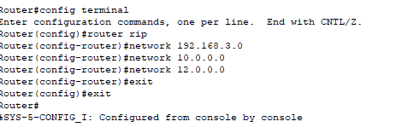
Show IP protocol
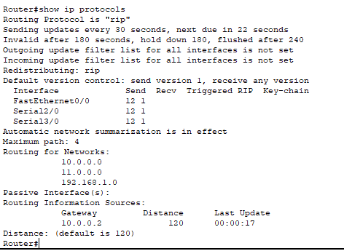

Static route for R1

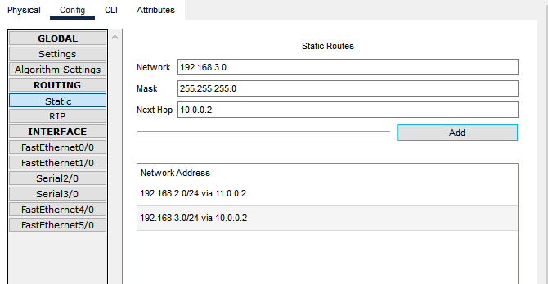
Static route for R2

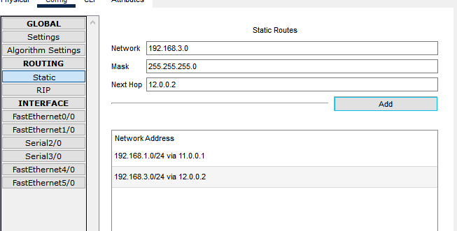
Static route for R3
